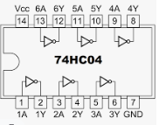

74HC595

Objetivo

Este chip da para 8 salidas mas, manejadas por medio de 3 entradas principalmente

* Data
* Latch
* Clock

0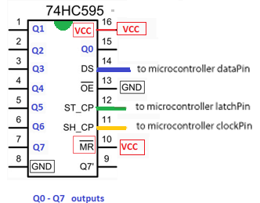

PIN 14 to store data

PIN 12 (Latch) Keep low while data is being written in PIN 14, once written move to HIGH

PIN 11 (Clock ) goes from LOW to HIGH the value of DS is tored into the shift register and the exiting values of the register are shifted to make room for the next bit Keep LOW while writing Data in Pin 14, once written move to HIGH

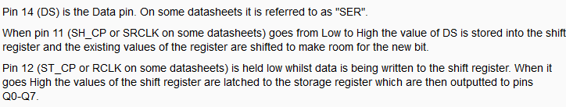

// To count from 0 to 255

// SE NECESITA 8 LEDS PARA Q0 – Q7

int latchPin = 8;

int clockPin = 12;

int dataPin = 11;

void setup() {

pinMode(latchPin, OUTPUT);

pinMode(clockPin, OUTPUT);

pinMode(dataPin, OUTPUT);

}

void loop() {

// count from 0 to 255 and display the number on the LEDs

for (int n = 0; n < 256; n++) {

// take the latchPin low so

// the LEDs don't change while you're sending in bits:

digitalWrite(latchPin, LOW);

// shift out the bits:

shiftOut(dataPin, clockPin, MSBFIRST, n);

//take the latch pin high so the LEDs will light up:

digitalWrite(latchPin, HIGH);

// pause before next value:

delay(500);

}

}

byte arreglo[9] = {

B00000000, B00000001, B00000011, B00000111,

B00001111, B00011111, B00111111, B01111111, B11111111,

};

|  |  |
| --- | --- |
| Binario | Entero |
| B00000000  B00000001  B00000011  B00000111  B00001111  B00011111  B00111111  B01111111  B11111111 | 0  1  3  7  15  31  63  127  256 |

El numero 24 seria el binario 00001100 encenderia el Q2 Y Q3

int dataPIN = 8; // conectado al PIN 14

int latchPIN = 9; // conectado al PIN 12

int clockPIN = 10; // conectado al PIN 11

setup {

pinMode(clockPin, OUTPUT);

pinMode(latchPin, OUTPUT);

pinMode(dataPin, OUTPUT);

}

// Tome valor entre 0 a 8

int cual ( from 0-8) // CALCULE EL VALOR

// Grabe valor

digitalWrite(latchPin, LOW); // VA A ESCRIBIR DATA

shiftOut(dataPin, clockPin, MSBFIRST, arreglo[cual]);

digitalWrite(latchPin, HIGH); // PROCESSED

Ejemplo:

* Poner Q0 – Q7 en apagado sera arreglo[0] con valor B00000000
* Poner Q0 – Q7 encendido sera arreglo[8] con valor B11111111

Endiende los LED y luego los apaga en secuencia

const int latchPin = 8;   // Pin conectado al Pin 12 del 74HC595 (Latch)

const int dataPin  = 9;   // Pin conectado al Pin 14 del 74HC595 (Data)

const int clockPin = 10; // Pin conectado al Pin 11 del 74HC595 (Clock)

int i =0;

const byte numeros[16] = {

               0b11111100,

               0b01100000,

               0b11011010,

               0b11110010,

               0b01100110,

               0b10110110,

               0b10111110,

               0b11100000,

               0b11111110,

               0b11100110,

               0b11101110,

               0b00111110,

               0b10011100,

               0b01111010,

               0b10011110,

               0b10001110

};

void setup() {

**Serial**.begin(9600);

 pinMode(latchPin, OUTPUT);

 pinMode(clockPin, OUTPUT);

 pinMode(dataPin, OUTPUT);

}

void loop() {

               for (i=0;i<16;i++) {

                              delay(1000);

                              digitalWrite(latchPin, LOW);

                              shiftOut(dataPin, clockPin, LSBFIRST, numeros[i]);

                              digitalWrite(latchPin, HIGH);

               }

}